 Beaconside CofE Primary School OPAL Play Charter 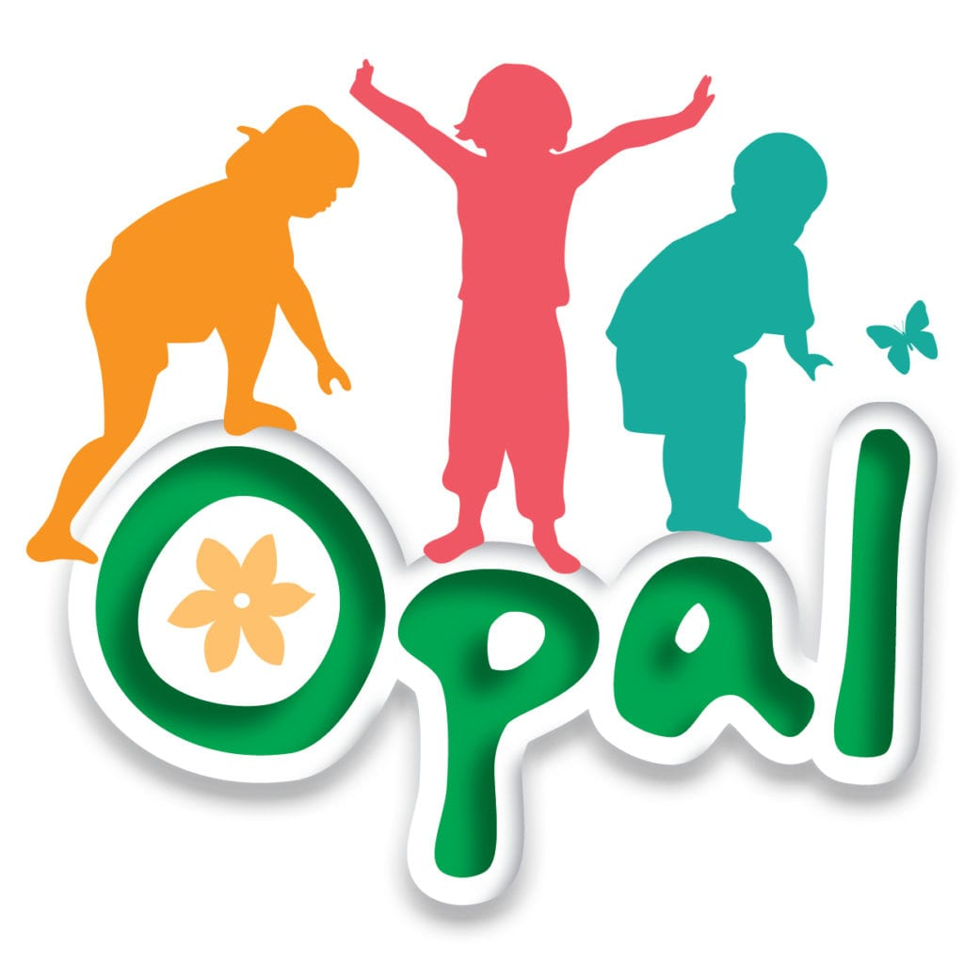
The United Nations says in its children’s rights agreement (Article 31) that all children have the right to play, relax, and enjoy their free time.
This charter is our promise to you that we will respect your right to play and have fun during lunchtime, as you follow our school rules of being Ready, Respectful and Safe, and show kindness and care to everyone.
- Play is a human right for everyone.
The adults at Beaconside CofE School will let you know this by valuing your right and need to play; you are free to choose what you do at OPAL lunchtimes- lively or relaxed, noisy or quiet- with the chance to stretch and challenge yourselves, take risks and enjoy freedom.

- Our lunchtime play is inclusive for everyone.
At our school, everyone has the time and space to play freely and confidently with friends, indoors and outdoors, where you feel safe.

- You can enjoy lots of different kinds of play. You can get dirty, feel challenged, are supported and can be independent.
Adults respect the value and importance of all types of play and create opportunities and time for you to play independently with your friends.

- You can enjoy free play, move around lots of different spaces and have fun in our natural setting.
You can play freely in our school grounds, exploring nature, the environment and being with your friends.

- Adults at lunchtime will help make your play as interesting and fun as they can.
You will have access to a choice of zones where adults are on-hand to support with your play if needed. Qualified and trained play leaders put your play at the centre of their work, and are helped by our OPAL play champions.

- Our school grounds are a fun place to play.
You will have time and space to play at school, with a lunchtime to relax and play freely with your friends. You will have zones to play in, which include loose parts, den building, wheeled toys, football, small world and a mud kitchen. You can also enjoy playing on rope swings and ladders, and tree climbing.

- You will get extra support if you need it to have a really good playtime.
Adults are always on-hand if you need some help whilst you’re playing. You might be feeling sad or having a difficult day, but the adults in school will help if you need it.
Our OPAL charter
We have the right to play and enjoy OPAL.
We have the responsibility to make sure everyone enjoys playtime by making sure:

- We are ready to play
* wellies, sunhats or other clothes for the weather
* equipment is not broken and we let an adult know if we spot something
* we’re ready to play and use our imaginations
* we’re ready to stop and tidy up at the end

- We treat each other with respect and how we like to be treated
* we share equipment fairly and kindly
* everyone chooses what to play
* we are kind to others
* we help people if they need us
* we allow people to join in games
* we listen to one another

- We keep everybody safe
* we check something feels safe before playing
* we ask for help if we need it
* we use a helmet when we need it
* we take care and play safely

Signed:………………………………………………………………………………………………………………………..

