Questful progression and sequencing


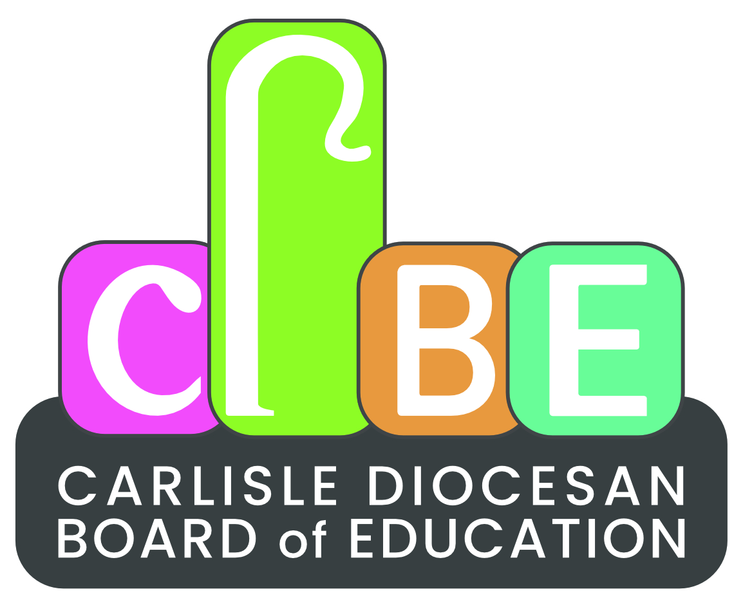


Themes
Christmas | Easter | The Church/  special buildings | Prayer | Harvest | Baptism | The Bible/  special books
People from the Bible | The Arts inc’ music | Jesus | God | People of Faith – lived experience | Stand-alone content | Stories

R&WV | Christianity | Islam | Judaism | Hinduism | Sikhism | Buddhism | Humanism
EYFS | EYFS 2 Harvest  Why do people of faith say thank you to God at harvest time? (UC F1)  EYFS 3 Special People Why do Christians believe Jesus is special?  EYFS 4 Christmas  How do Christians celebrate Jesus’ birthday?  (UC F2)  EYFS 7 Easter  Why do Christians believe that Easter is all about love? (UC F3)  EYFS 9 Special Places What makes a place holy?  EYFS 10 Prayer  What is prayer? | EYFS 9 Special Places What makes a place holy?  EYFS 10 Prayer  What is prayer? | EYFS 10 Prayer  What is prayer? | EYFS 9 Special Places What makes a place holy? |  | EYFS 10 Prayer  What is prayer?
Y1 | 1.1 Harvest  How can we help those who do not have a good harvest?  1.3 Christmas  Why do we give and receive gifts? (UC 1.3)  1.5 Easter  What do you think is the most important part of the Easter story? (UC 1.5)  1.7 Baptism  Why is Baptism special?  1.9 My world Jesus world  How is the place where Jesus lived different from how we live now?  Supplementary Unit:  Unit S3 – Old Testament  What does this story teach us about God? | 1.7 Baptism  Why is Baptism special?  Unit S3 – Old Testament  What does this story teach us about God? | 1.1 Harvest  How can we help those who do not have a good harvest?  Unit S3 – Old Testament  What does this story teach us about God? | 1.7 Baptism  Why is Baptism special?  Unit S3 – Old Testament  What does this story teach us about God? | 1.7 Baptism  Why is Baptism special?  Unit S3 – Old Testament  What does this story teach us about God? |  | 1.7 Baptism  Why is Baptism special?
Y2 | 2.1 The Bible  Why is the Bible such a special book?  2.2 Christmas  Why was the birth of Jesus such good news? (UC 1.3)  2.4 Easter  How do symbols help us to understand the Easter story? (UC 1.5)  2.5 The Church  Why is the church a special place for Christians?  Supplementary Unit:  Unit S1 – Holy Week  What happened during Holy Week?  Unit S9 – New Testament  Which part of the story do you like best? | 2.1 The Bible  Why is the Bible such a special book?  2.5 The Church  Why is the church a special place for Christians? | 2.1 The Bible  Why is the Bible such a special book?  2.5 The Church  Why is the church a special place for Christians? | 2.5 The Church  Why is the church a special place for Christians? | 2.1 The Bible  Why is the Bible such a special book?
Y3 | 3.1 Called by God What does it mean to be called by God? (UC 2a.2)  3.2 Christmas  How does the presence of Jesus impact on people’s lives?  3.4 Easter  Is the cross a symbol of sadness or joy? (UC 2a.5)  3.5 Rules for living Which rules should we follow?  3.6 Harvest  How do people of faith say thank you to God for the harvest?  Supplementary Unit:  Unit S12 – Peace  What is peace? | 3.1 Called by God What does it mean to be called by God?  3.5 Rules for living Which rules should we follow?  Unit S12 – Peace  What is peace? | 3.1 Called by God What does it mean to be called by God?  3.6 Harvest  How do people of faith say thank you to God for the harvest?  Unit S12 – Peace  What is peace? | 3.1 Called by God What does it mean to be called by God?  3.6 Harvest  How do people of faith say thank you to God for the harvest?  Unit S12 – Peace  What is peace? | 3.1 Called by God What does it mean to be called by God?  3.5 Rules for living Which rules should we follow?  Unit S12 – Peace  What is peace? | 3.5 Rules for living Which rules should we follow?  Unit S12 – Peace  What is peace? | 3.5 Rules for living Which rules should we follow?
Y4 | 4.2 Christmas  Why is Jesus described as the light of the world?  4.3 Jesus  Why do Christians believe Jesus is the Son of God?  4.4 Easter  A story of betrayal or trust?  4.5 The Church  Are all churches the same?  4.6 Prayer  What is prayer?  Supplementary Unit:  Unit S8 – Lent  Why is Lent a special season in the church calendar? | 4.4 Easter  A story of betrayal or trust?  4.5 The Church  Are all churches the same?  4.6 Prayer  What is prayer? | 4.2 Christmas  Why is Jesus described as the light of the world?  4.3 Jesus  Why do Christians believe Jesus is the Son of God?  4.4 Easter  A story of betrayal or trust?  4.5 The Church  Are all churches the same?  4.6 Prayer  What is prayer? | 4.4 Easter  A story of betrayal or trust?  4.5 The Church  Are all churches the same?  4.6 Prayer  What is prayer? | 4.4 Easter  A story of betrayal or trust?  4.5 The Church  Are all churches the same? | 4.6 Prayer  What is prayer?
Y5 | 5.1 The Bible  How and why do Christians read the Bible?  5.4 Easter  Why do Christians believe that Easter is a celebration of Victory? (UC 2b.6)  5.5 Old Testament Women  Did she make the right choice?  5.6 Loss Death and Christian hope  Is death an ending or a beginning?  5.7 Christmas  How is Christmas celebrated around the world?  Supplementary Unit:  Unit S5 – Christian Art  How do Christians express their faith through art? | 5.1 The Bible  How and why do Christians read the Bible?  5.6 Loss Death and Christian hope  Is death an ending or a beginning?  Unit S5 – Christian Art  How do Christians express their faith through art? | 5.1 The Bible  How and why do Christians read the Bible?  5.5 Old Testament Women  Did she make the right choice?  Unit S5 – Christian Art  How do Christians express their faith through art? | 5.1 The Bible  How and why do Christians read the Bible?  5.6 Loss Death and Christian hope  Is death an ending or a beginning?  Unit S5 – Christian Art  How do Christians express their faith through art? | 5.1 The Bible  How and why do Christians read the Bible? | 5.6 Loss Death and Christian hope  Is death an ending or a beginning? | 5.6 Loss Death and Christian hope  Is death an ending or a beginning?
Y6 | 6.2 Advent  How do Christians prepare for Christmas?  6.3A The Exodus  Why is the Exodus such a significant event in Jewish and Christian history?  (Judaism/Jesus links)  6.6 God  What is the nature and character of God?  (UC 2b.1)  6.7 People of faith How does having faith affect people’s lives?  Supplementary Unit:  Unit S7 – Change the World  How can I make a difference?  Unit S6 – Easter around the World  How do Christians around the world celebrate Easter? | 6.6 God  What is the nature and character of God?  6.7 People of faith How does having faith affect people’s lives?  Unit S7 – Change the World  How can I make a difference? | 6.3A The Exodus  Why is the Exodus such a significant event in Jewish and Christian history?  Unit S7 – Change the World  How can I make a difference? | 6.6 God  What is the nature and character of God?  6.7 People of faith How does having faith affect people’s lives?  Unit S7 – Change the World  How can I make a difference? |  | 6.7 People of faith How does having faith affect people’s lives?  Unit S7 – Change the World  How can I make a difference?

Supplementary units | KS1 S1 Holy Week  What happened during Holy Week?  KS1 S3 Old Testament What does this story teach us about God?  KS1 KS2 S5 Christian Art  How do Christians express their faith through art?  KS1 KS2 S6 Easter around the world  How do Christians around the world celebrate Easter?  KS2 S7 Change the world  How can I make a difference?  KS2 S8 Lent  Why is Lent a special season in the church calendar?  KS2 S12 Peace  What is peace? | KS1 S3 Old Testament What does this story teach us about God?  KS1 KS2 S5 Christian Art  How do Christians express their faith through art?  KS2 S7 Change the world  How can I make a difference?  KS2 S12 Peace  What is peace? | KS1 S3 Old Testament What does this story teach us about God?  KS1 KS2 S5 Christian Art  How do Christians express their faith through art?  KS2 S7 Change the world  How can I make a difference?  KS2 S12 Peace  What is peace? | KS1 S3 Old Testament What does this story teach us about God?  KS1 KS2 S5 Christian Art  How do Christians express their faith through art?  KS2 S7 Change the world  How can I make a difference?  KS2 S12 Peace  What is peace?  Inter Faith Week:  EYFS KS1 KS2 S14 Diwali  Why do Hindus light candles at Diwali? | KS1 S3 Old Testament What does this story teach us about God?  KS2 S12 Peace  What is peace? | KS2 S7 Change the world  How can I make a difference?  KS2 S12 Peace  What is peace?

Concepts | God | Creation | Fall | People of God | Incarnation | Gospel | Salvation | Kingdom of God
EYFS | EYFS 2 Harvest  EYFS 9 Special Places  EYFS 10 Prayer  EYFS 11 Special Times | EYFS 2 Harvest |  |  | EYFS 4 Christmas |  | EYFS 7 Easter
Y1 | - Harvest  1.7 Baptism | 1.1 Harvest |  | 1.8 Joseph | - Christmas  1.9 My world Jesus world | 1.1 Harvest | 1.5 Easter  1.7 Baptism
Y2 | 2.1 The Bible | 2.1 The Bible | 2.1 The Bible | 2.1 The Bible  2.5 The Church | 2.1 The Bible  2.2 Christmas | 2.1 The Bible  2.5 The Church | 2.1 The Bible  2.4 Easter | 2.1 The Bible  2.5 The Church
Y3 | 3.6 Harvest | 3.6 Harvest | 3.5 Rules for living | 3.1 Called by God  3.5 Rules for living | 3.2 Christmas | 3.5 Rules for living | 3.4 Easter
Y4 | 4.6 Prayer |  |  |  | 4.2 Christmas  4.3 Jesus | 4.3 Jesus  4.5 The Church | 4.2 Christmas  4.3 Jesus  4.4 Easter | 4.5 The Church
Y5 | 5.1 The Bible | 5.1 The Bible | 5.1 The Bible | 5.1 The Bible  5.5 Old Testament Women | 5.1 The Bible  5.2 Christmas  5.7 Christmas | 5.1 The Bible | 5.1 The Bible  5.2 Christmas  5.4 Easter  5.6 Loss Death and Christian hope | 5.1 The Bible
Y6 | 6.6 God |  |  | 6.2 Advent  6.3A The Exodus |  | 6.1 Life as a journey  6.2 Advent |  | 6.2 Advent  6.7 People of faith
Supplementary units | KS1 KS2 S5 Christian Art  KS2 S7 Change the world | KS1 KS2 S5 Christian Art  KS2 S7 Change the world | KS1 KS2 S5 Christian Art  KS2 S7 Change the world | KS1 S3 Old Testament  KS1 KS2 S5 Christian Art  KS2 S7 Change the world | KS1 KS2 S5 Christian Art  KS2 S7 Change the world | KS1 S1 Holy Week  KS1 KS2 S5 Christian Art  KS2 S7 Change the world  KS2 S8 Lent | KS1 S1 Holy Week  KS1 KS2 S5 Christian Art  KS1 KS2 S6 Easter around the world  KS2 S7 Change the world  KS2 S8 Lent | KS1 KS2 S5 Christian Art  KS2 S7 Change the world  KS2 S12 Peace

